EXPERIMENT-4

SINGLE-PHASE

AIM:

To represent a single phase and three phase system and explain the working.

THEORY:

A single-phase electrical transmission system is practically not available, but still we should know the basic concept of single phase power first before going through modern three phase power system. Before going to details about single-phase power, let’s try to understand different parameters of electrical power system. Three basic parameters of electrical power system are electrical resistance, inductance and capacitance.

MULTISIM:

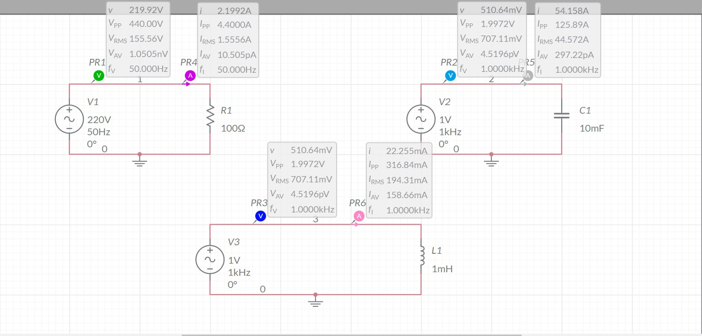

GRAPHS:

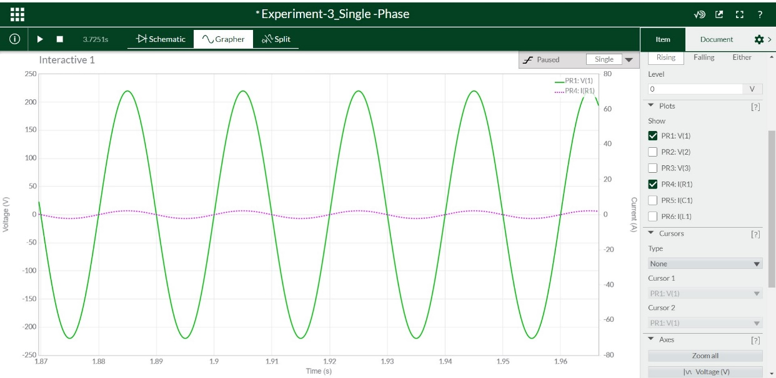

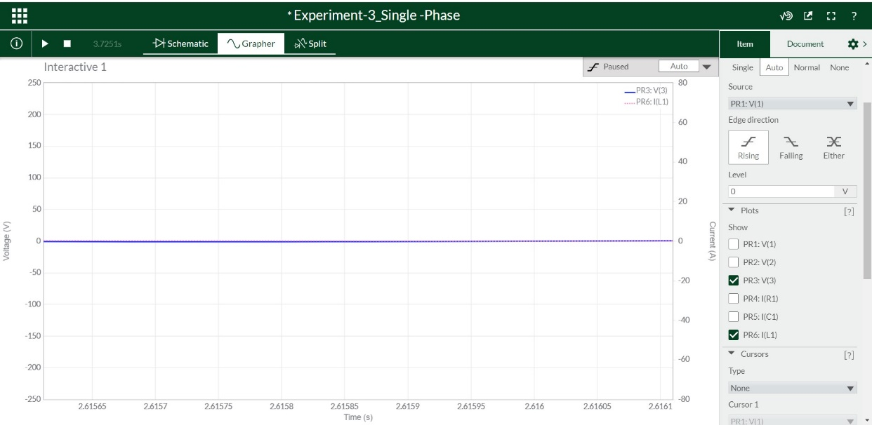

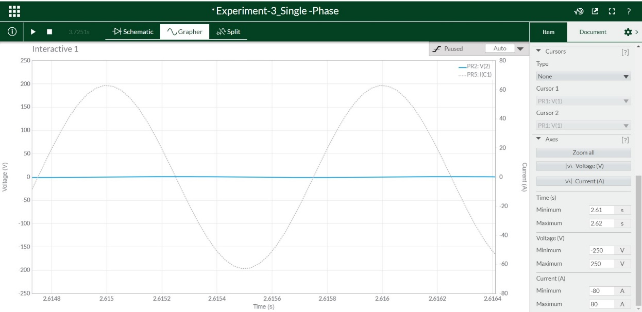

THREE-PHASE

THOERY:

In a three-phase system, three circuit conductors carry three alternating currents (of the same frequency) which reach their instantaneous peak values at different times. Taking one conductor as the reference, the other two currents are delayed in time by one-third and two-thirds of one cycle of the electrical current. This delay between "phases" has the effect of giving constant power transfer over each cycle of the current, and also makes it possible to produce a rotating magnetic field in an electric motor.

Three phase systems may or may not have a neutral wire. A neutral wire allows the three -phase system to use a higher voltage while still supporting lower voltage single phase appliances. In high voltage distribution situations it is common not to have a neutral wire as the loads can simply be connected between phases (phase-phase connection).

MULTISIM:

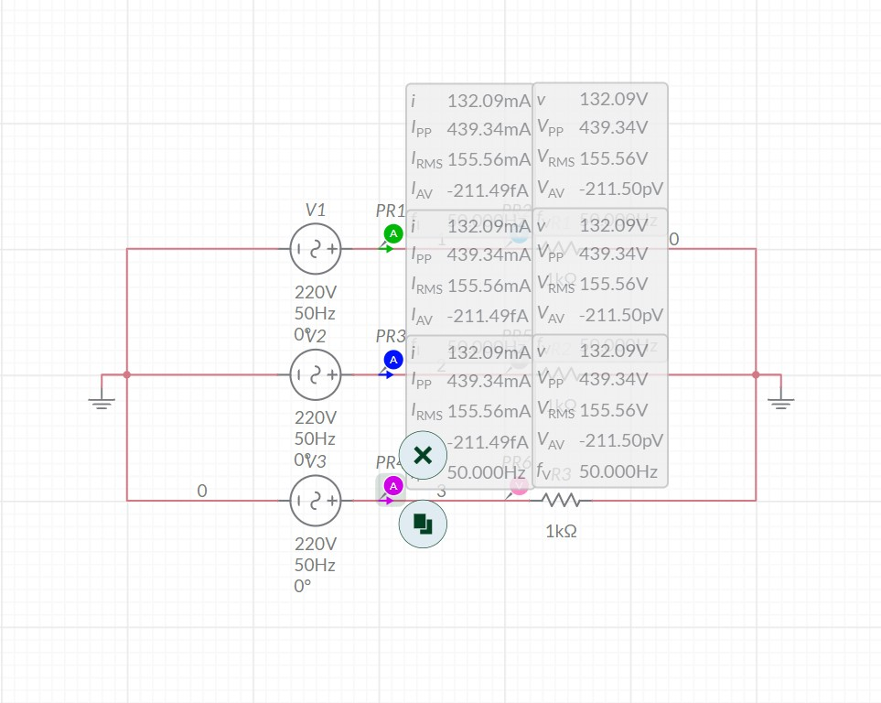

GRAPHS:

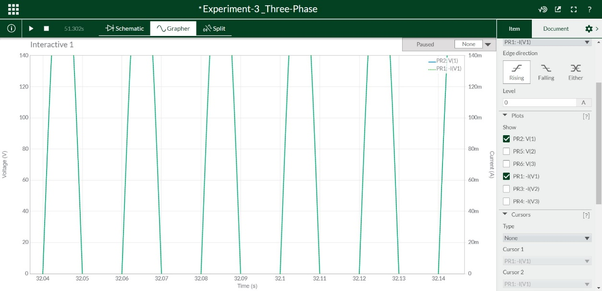

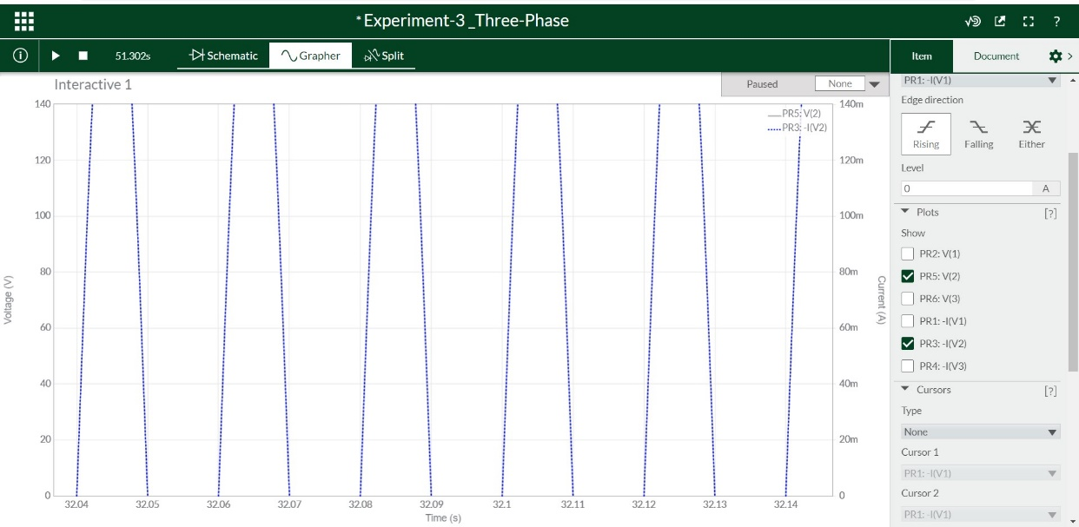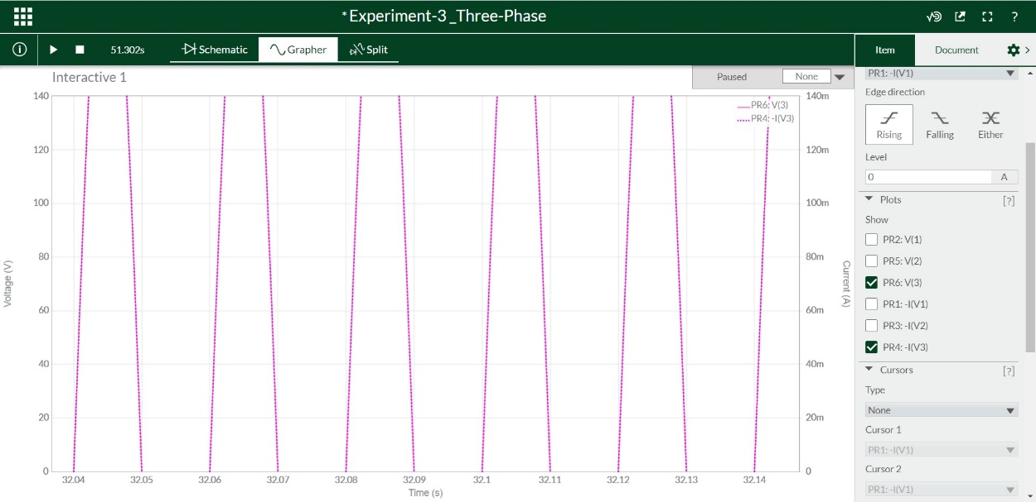

NAME: G R NITIN

ROLL NO: CB.EN.U4CYS21017